**Problem Name:** Ganga Yamuna water flow

**Topics:**

**Companies:**

**Level:** Easy

**Language:** C++

**Problem Statement**:

Doge is solving a DSA problem but he is having some difficulty with it. Can you help Doge so that he can complete it and play with his friend Cheem?

Problem is:

**Input Format:**

The first line of input is an integer value n (total no of vertex in the graph).

The Second line of input contains integer value m (total no of edges in the graph)

The next m lines contain two space-separated integers forming a graph.

Last line of input contains the integer value source and destination

**Output Format:**

**Constraints:**

**Examples:**

**Approach one Solution:**

**Explanation:**

In a naive approach, we would have to consider each cell and find if it is reachable to both the oceans by checking if it is able to reach - **1.** top or left edge(atlantic) and, **2.** bottom or right edge (pacific). This would take about **O((mn)^2)**, which is not efficient.

***Solution - I (DFS Traversal)***

I will try to explain the process using images provided in LC solution.

We can observe that there are these cells which can reach -

* None
* Pacific
* Atlantic
* Both Pacific and Atlantic

We need only the cells satisfying the last condition above.

Now, if we start from the cells connected to altantic ocean and visit all cells having height greater than current cell (**water can only flow from a cell to another one with height equal or lower**), we are able to reach some subset of cells (let's call them **A**).

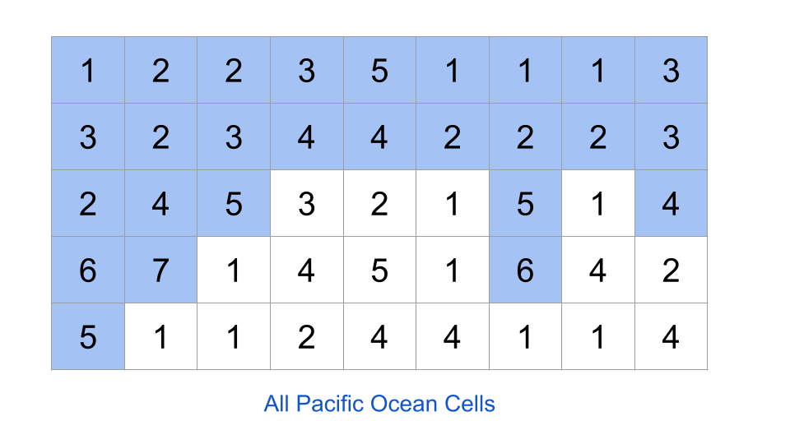

Next, we start from the cells connected to pacific ocean and repeat the same process, we find another subset (let's call this one **B**).

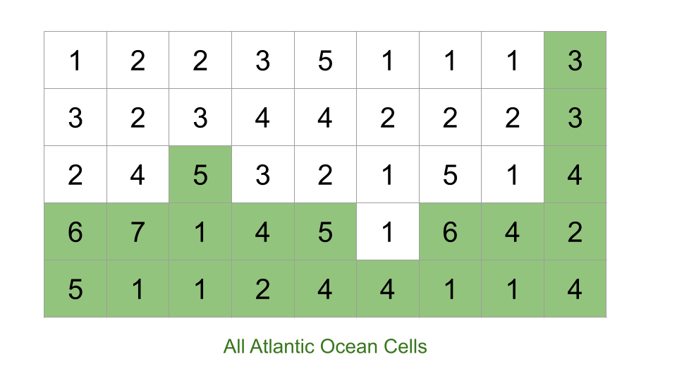

The final answer we get will be the intersection of sets A and B (**A ∩ B**).

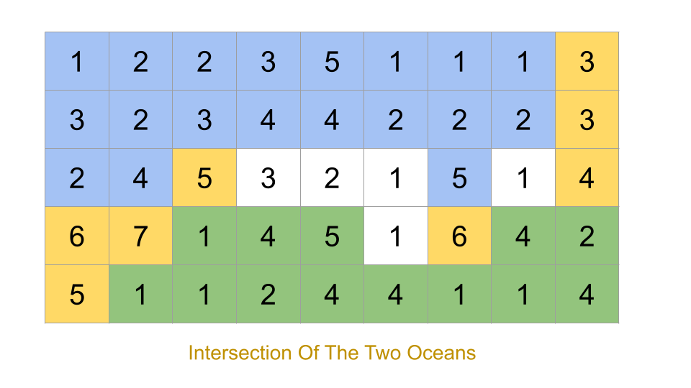

So, we just need to iterate from edge cells, find cells reachable from atlantic (set A), cells reachable from pacific (set B) and return their intersection. This can be done using DFS or BFS graph traversals.

**Code:**

**Time Complexity :** **O(M*N)**, in worst case, all cells are reachable to both oceans and would be visited twice. This case can occur when all elements are equal.  
**Space Complexity :** **O(M*N)**, to mark the atlantic and pacific visited cells.

**Approach second Solution:**

Explanation: BFS

Below is similar solution as above converted to **BFS traversal** -

**Code:**

**Time Complexity**: No.of Pixels i.e., O(N)

**Space Complexity:** No of dfs calls(Nothing but no.of pixels in worsecase) O(N).